**Indicator Activity Instructions**

**Overview**

Resilience indicators can help practitioners and policy makers understand costs and benefits of enhancing resilience at all scales. For more information about what indicators are and how they are used in this tool, read the **Resilience Indicators Background** at the end of this document.

## Objective

To assess which indicators are most or least resilient and most or least equitable, and where systems and topics fall on resilience and equity continuums.

## Preparation

**Who will be involved:** workshop participants, facilitators

**Where:** in-person or virtual workshop

**Suggested activity length:** 1-2 hours

**Materials:** completed indicator cards (printed or virtual, see instructions in the Indicator Center to prepare cards), large tables (in-person)

**Output**

Sorted hazard, equity, and resilience indicator cards to help assess where your community might focus their attention and prioritize goals.

**Indicator Activity Instructions**

## Instructions

1. **(Core team)**: Create indicator cards using the template at the end of this document to use in the activity. The ERB downloadable tool has a list of suggested resilience indicators for the social, built, and natural environment such as:

 **Tip**:

Start with a small set of indicators based on topics brought up in previous community storytelling exercises. New indicators can be added at any time.

* Multi-lingual disaster communication (social environment)
* Access to cooling spaces (built environment)
* Parks, green spaces and blue spaces (natural environment)

You can also develop your own indicators based on key community concerns that you have learned about in the other Assess activities like storytelling or mapping, or based on data you have collected on hazards and equity.

Once you have the list of indicators you would like to use, fill out the cards with any data or information you have. Include a description or definition of the indicator that is understandable to community members. If you have access to any data or local information about the indicator you can include it on the card as well. If you don’t have any further information leave those spaces blank.

Print out the cards (size?) and bring them to the workshop.

1. **(Community members):** Divide into breakout groups for each of the resilience systems (built, natural, and social). Make sure the indicator cards in your group correspond to the same resilience system.
2. **(Breakout groups)**: As a group, arrange cards along a horizontal line from least to most resilient as shown in the image below.
   1. Less resilient: Very vulnerable/susceptible to damage or disruption and would likely take a long time to recover from a shock.
   2. More resilient: Minimally vulnerable/susceptible to damage or disruption and would likely be able to withstand shocks or recover quickly.

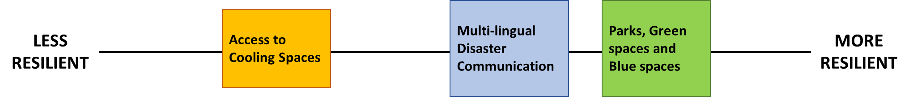

Indicator Diagram with Cards Sorted by Resilience: An example of how the indicator cards should be sorted horizontally from less resilient to more resilient.

1. **(Breakout groups)**: Now as a group, move the cards you just placed on the resilience line up or down to indicate how equitable each indicator is as shown in the image below.
   1. Less equitable: There are substantial differences in how different groups of people or neighborhoods are affected by this indicator which cause greater harm or risks for some groups.
   2. More equitable: There are minimal differences in how different groups of people or neighborhoods are affected by this indicator or if there are differences, they do not cause greater harm or risk for a particular group.
   3. Example: For the indicator “Number of homes in FEMA floodplain”, there could be a low number of homes in floodplains (more resilient), but the homes in the floodplains belong to low-income families or persons over 65 (less equitable).

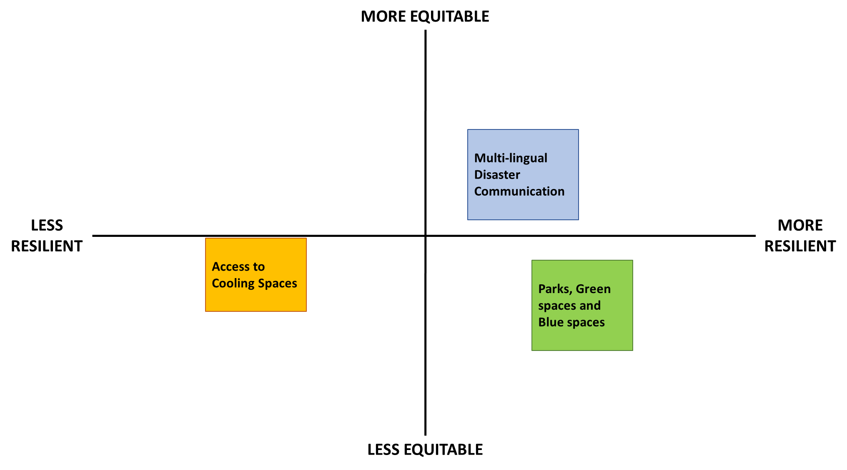

Indicator Diagram with Cards Sorted by Equity: An example of how the indicator cards should be sorted vertically from less equitable to more equitable after sorted based on resilience.

1. **(Core team)**: Have each breakout group share their results and discuss as a group the patterns you see. This can be done with tape or sticky notes on a wall, projector, or table. Draw squares around the 4 quadrants on the board and add labels to each quadrant following the example below.

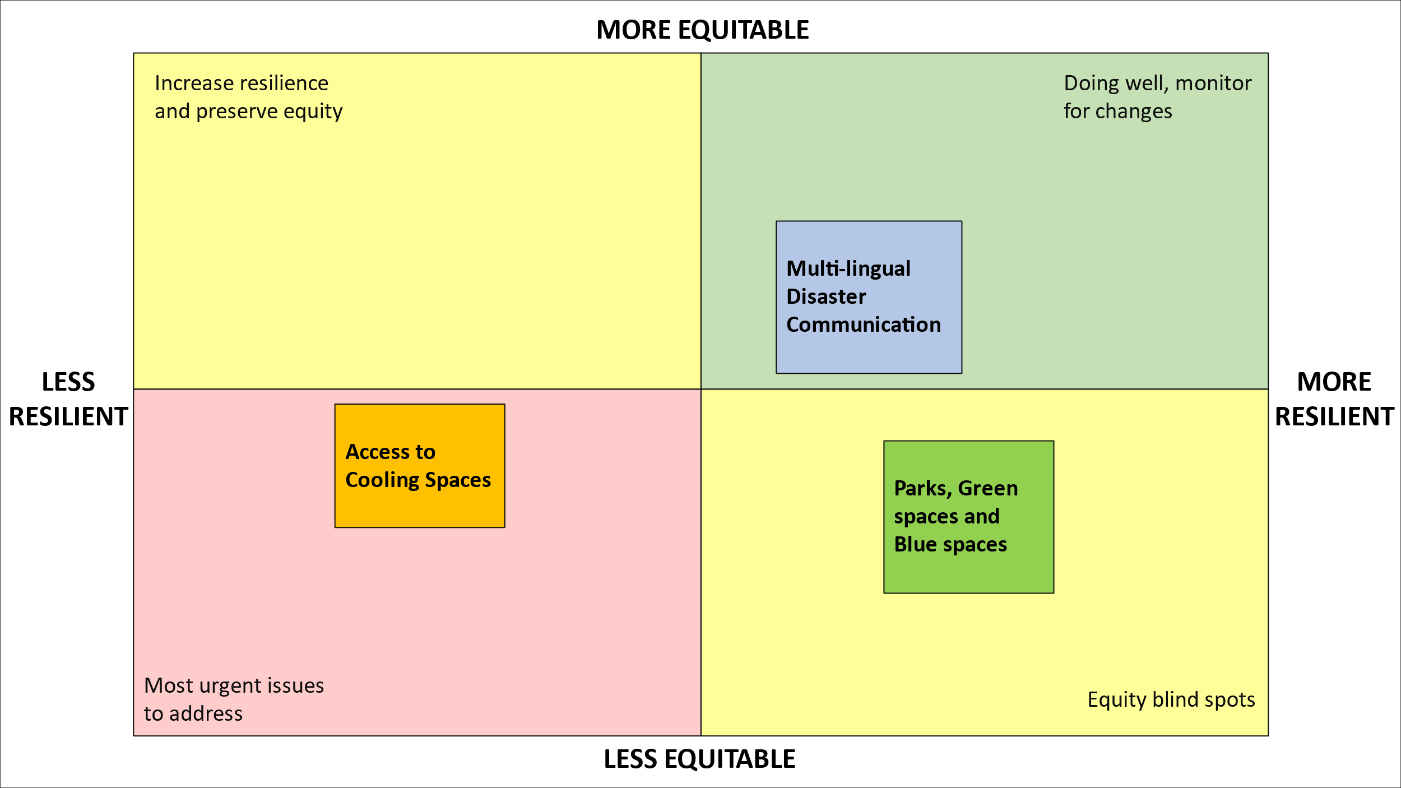

*Indicator Diagram with Cards in Quadrants:*

*An example of fully sorted indicator cards from all systems. Quadrants are labeled as a group after breakout groups have sorted their cards.*

## Large group discussion prompts

1. Which quadrants have the most cards? Do you feel this is an accurate picture of the overall resilience and equity of the community?
2. Are there certain systems that show up more often as more or less resilient, or more or less equitable?
3. Are there certain hazards that present a greater risk for the community than others? Are there certain systems that are more vulnerable to specific hazards (as discussed during the hazard mapping activity)?

**Resilience Indicators Background**

Community resilience to extreme events, hazards, or changes in environmental conditions because of climate change can be improved with increased awareness of potential risks. Resilience indicators identify sources of potential vulnerability so that further assessment and targeted adaptation strategies can be taken.

**What is a resilience indicator?**

Resilience indicators are summary measures that provide information on the state of or change in built, social, or natural systems that can help characterize their vulnerability and adaptive capacity. Indicators can help community leaders assess needs, prioritize goals, and establish baselines for monitoring progress and recognizing success [1].

However, community indicators are often based on national data sets and assumptions that do not make sense for every community. To be useful for community planning, indicators need to be developed with input from local leaders and community members and tailored to assess local context.

**Using the Equitable Resilience Builder (ERB) to assess hazards, equity, and resilience**

The ERB tool offers an iterative process for integrating community data on hazards and equity to develop and identify indicators so that further assessment and targeted adaptation strategies can be undertaken in an equitable, resource-effective manner [2].

*Figure 1. Indicators in ERB*

Resilience indicators can also help practitioners and policy makers understand costs and benefits of enhancing resilience at all scales. Importantly, resilience indicators can provide insight into the complexity, interdependence, and uncertainty that exists in communities and vulnerability to external events or stressors.

**Resources to learn more:**

* FEMA. 2022. *Commonly Used Indicators from Peer-Reviewed Research.* Washington, D.C., Federal Emergency Management Agency. <https://www.fema.gov/sites/default/files/documents/fema_2022-community-resilience-indicator-analysis.pdf>
* FEMA. *Resilience Analysis and Planning Tool.* Washington, D.C., Federal Emergency Management Agency. <https://fema.maps.arcgis.com/apps/webappviewer/index.html?id=90c0c996a5e242a79345cdbc5f758fc6>
* U.S. EPA. 2017. *Evaluating Urban Resilience to Climate Change: A Multi-Sector Approach (Final Report).* U.S. Environmental Protection Agency, Washington, D.C., EPA/600/R-16/365F.

**References**

[1] Cutter. 2016. The landscape of disaster resilience indicators in the USA. *Natural Hazards* 80, 741–758. <https://doi.org/10.1007/s11069-015-1993-2>

[2] Sinha, et al. 2022. Assessing Community Vulnerability to Extreme Events in the Presence of Contaminated Sites and Waste Management Facilities: An Indicator Approach. <https://papers.ssrn.com/sol3/papers.cfm?abstract_id=4232780>