# **Exploring Equity Exercise**

## Overview

## Objective

To learn more about what it means to center equity in resilience planning and discuss how you can do this in your project.

## Preparation

**Who will be involved:** core team

**Suggested activity length:** 1 hour

**Materials:** copies of this document for everyone, pens, or pencils

**Before starting the exercise:** set up a meeting with the core team for a discussion and brainstorming about how to incorporate equity into your project. You could share the **Equitable Resilience Guide** with them ahead of time or bring it to the meeting.

## Output

An understanding of equity principles that you can refer to throughout your project such as when setting goals, planning workshops and activities with community members, reflecting on progress, and planning next steps.

# **Exploring Equity Exercise**

## Instructions

1. Review the Equitable Resilience Guide as a team.
2. Discuss what it means to center equity in resilience planning and discuss how you can do this in your project. You can use the discussion prompts below to facilitate your discussion, if needed.

## Discussion Prompts

1. What questions do you have about centering equity in your resilience planning? Is there anything you feel like you need more information about?
2. What equity issues have you encountered in your own experience or field of expertise that might be relevant to resilience planning? Do you have any experiences or lessons learned that could be helpful in your ERB project?
3. Thinking about the Equity Principles for Resilience Planning, what are some ways that you could make sure that your process centers equity?
4. What language do we want to use to talk about these issues? Some might prefer to use fairness over equity or extreme weather over climate change. The word disaster might spark different emotions. Use the terms that work best given local communities and cultures.

# **Equitable Resilience Guide**

|  |
| --- |
| Guide outline:   * Concepts, knowledge, and definitions on youth engagement * Building culturally appropriate, participatory, and community-centered resilience   + Impacts of Inequitable Planning   + Risks of worsening disparities and burdens on vulnerable communities * Best practices for meaningful engagement   + Addressing bias   + Centering diversity, equity, and inclusion   + Employing non-traditional methods   + Ethically protecting youth   This guide includes:   * Key ERB activities for planning and community building * References and resources for further engagement |

## Definitions and importance

As planners and practitioners prepare for increased environmental hazards and climate risks, care must be taken to ensure that adaptation and resilience measures do not inadvertently add to disproportionate burdens. Local leaders are increasingly recognizing that deliberate attention to rectifying historic inequities is required to improve adaptive capacity and support equitable resilience.

Equitable resilience describes the capacity to withstand, respond, adapt, and transform in the face of climate change and disasters in ways that are culturally appropriate, are participatory, and enhance the resilience of the community, not just individual resilience. Equitable resilience acknowledges deeply rooted social forces that affect how community members are made vulnerable to disaster and climate risk, may experience cascading consequences of incidents, and bear disproportionate benefits and burdens of actions to increase resilience.

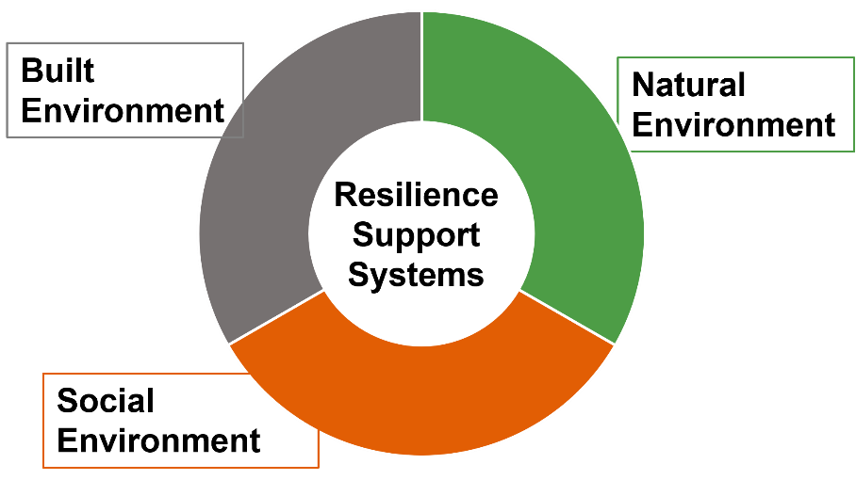  
*Social, built, and natural environment systems support community resilience.*

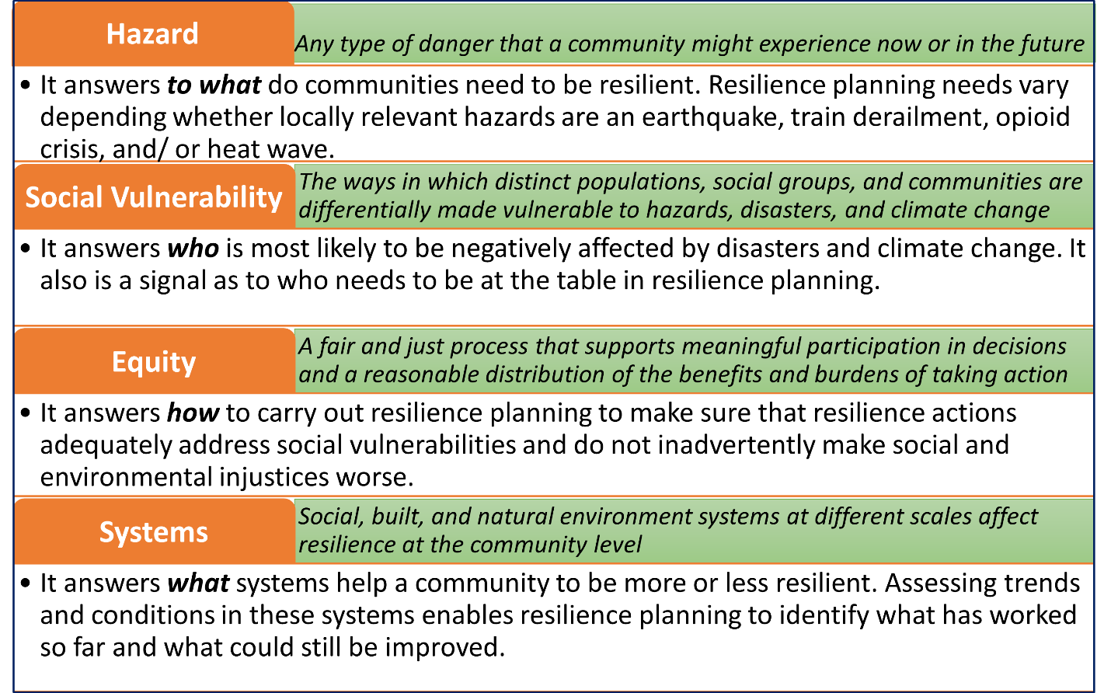

Key Terms: Definitions of key terms (hazard, social vulnerability, equity, and community resilience system) that ERB uses

# **ERB Activity Table: potential ERB activities, outputs, and impacts**

|  |  |  |
| --- | --- | --- |
| ERB Activity | Outputs for Resilience Planning | Community Building Around Resilience |
| **Gather data on hazards, equity, and resilience systems** | Baseline information from online datasets and recent planning documents; close data gaps | Increase understanding of how systems connect and relate; share information |
| **Storytelling on**  **hazards and assets** | Integrate local knowledge and diverse experiences into baseline information | Empower residents, strengthen networks, build empathy and trust |
| **Futures scenario** | Focused discussions about future risks people might not have considered | Integrate risk and equity assessments into planning |
| **Participatory mapping** | Spatial awareness of hazard impacts and community assets, integrate local knowledge and diverse experiences into baseline information | Identify priorities for action |
| **Indicator card sorting** | Resilience assessment of built, natural, and social systems, including existing disparities, integrate local knowledge into baseline information | Empower residents, identify priorities for action |
| **Equity discussion** | Awareness of root causes for who might experience hazards differently, how, and why, and equity considerations to address when designing resilience actions | Shared understanding of history and trauma, trust building, strengthen community connections, identify priorities for action |

## How Do Communities Benefit from the ERB Tool?

* Relationships: A stronger network of community organizations and agencies to share information and resources
* Recognition: Facilitation guides for holding workshops in trauma-informed ways, activity guides for soliciting community perspectives, and local knowledge is valued and utilized alongside scientific data
* Information: Data and maps on hazards, equity, and resilient community systems, and locally meaningful and measurable indicators to measure future change in built, natural, and social environment systems
* Action: A collaboratively prioritized set of actions and next steps for strengthening community resilience in an equitable way

## Equity Principles for Resilience Planning

An equitable process…

…is inclusive and accessible. “Inclusion is the act of creating environments in which any individual or group can be and feel welcomed, respected, supported, and valued to fully participate where differences are embraced. An inclusive and welcoming climate of the organization embraces differences and offers respect in words and actions for all people” [1]. Being inclusive also means ensuring the process is accessible, particularly for communities of color, low-income populations, and other often excluded groups.

...is accountable. The process should follow through on promises and communicates transparently about progress or setbacks towards goals. It should ensure that communities are benefitted and not harmed by the process.

…promotes justice. The process should acknowledge and attempt to reduce historical or current disparities to the extent possible.

…builds relationships. The process should build connections and relationships among people, organizations, and communities. Relationships foster a sense of belonging, and they are critical ways that information, resources, and opportunities are distributed, particularly in the aftermath of disasters.

…strengthens capacity of underserved communities. The process should share financial, technical, and social resources that strengthen the ability of underserved community members to participate fully, take leadership roles, and increase their self-determination.

## References

[1] Fang, Hench, Daniels, and Walton. 2022. Centering Equity in Climate Resilience Planning and Action: A Practitioner’s Guide. Climate-Smart Communities Series, 3. Antioch University New England. DOI: 10.25923/765q-zp33

[2] NAACP. 2023. Core Principles of Equity and Emergency Management. <https://naacp.org/resources/core-principles-equity-and-emergency-management>