Thank you for joining our second Crisfield/EPA ORD Technical Working Group (TWG) providing technical feedback on proposed nature-based solutions (NBS) and co-benefits for Crisfield’s coastal resilience!

AGENDA for October 2:

* Review top three NBS and potential ecosystem characteristics they could change
* Refine measures and data sources to assess NBS co-benefits

Attendees:

|  |  |
| --- | --- |
| **Organization** | **Expertise** |
| City of Crisfield | Local knowledge, funding |
| Federal Emergency Management Agency, Region 3, Building Resilient Infrastructure and Communities Direct Technical Assistance (BRIC DTA) program | Crisfield flood mitigation plan |
| Maryland Department of Natural Resources, Janes Island State Park | Local state park use, recreation, tourism, park management |
| National Oceanic and Air Administration (NOAA) Fisheries, Restoration Center | Local fisheries habitat |
| Lower Shore Land Trust | Local marsh knowledge |
| Somerset County Public Works | Local engineering, dredging |
| University of Maryland, Environmental Finance Center | Finance and green infrastructure |
| Maryland Department of Planning | Planning |
| Sustainable Science, LLC | Salt marsh restoration |
| EPA Office of Research and Development | Project Navigator |
| EPA Office of Research and Development | Ecosystem co-benefits |
| EPA Office of Research and Development | Community engagement |
| EPA Office of Research and Development | Evaluation, community capacity |

One of the most important types of benefits of NBS identified by Crisfield is obviously the storm surge attenuation capabilities of these projects. We are also exploring the extent to which we can assess and compare the erosion prevention capabilities, as part of the overall coastal resilience component of NBS. Preliminary results from coastal storm attenuation modeling of top 3 NBS expected around December.

We also recognize that there are other different types of benefits that Crisfield is interested in that these projects will also be able to provide to some extent (e.g., around fisheries, tourism, water quality, etc.). So that is what we wanted to focus this meeting on --- to have a more detailed discussion of these kinds of co-benefits, one by one, and to get a sense of whether we think these kinds of proposed nature-based strategies will significantly impact benefits of most interest to Crisfield, and how best to measure those impacts them. Some projects may not affect some types of benefits, in which case, it does not make sense to keep them in the analysis. We want to highlight the co-benefits we think will be changing the most as a result of implementing any of the top 3 proposed projects, and get a sense of whether the metrics we are proposing to measure these benefits make the most sense or if anyone has other ideas about which metrics to measure. We’d also like to triage co-benefits to identify most important ones.

We have spent other meetings leading up to how we are currently looking at these three possible nature-based strategies for Crisfield, and we are currently in the process of converting these strategies into modeling inputs with our engineering contractors, but as a reminder, here are the 3 top NBS:

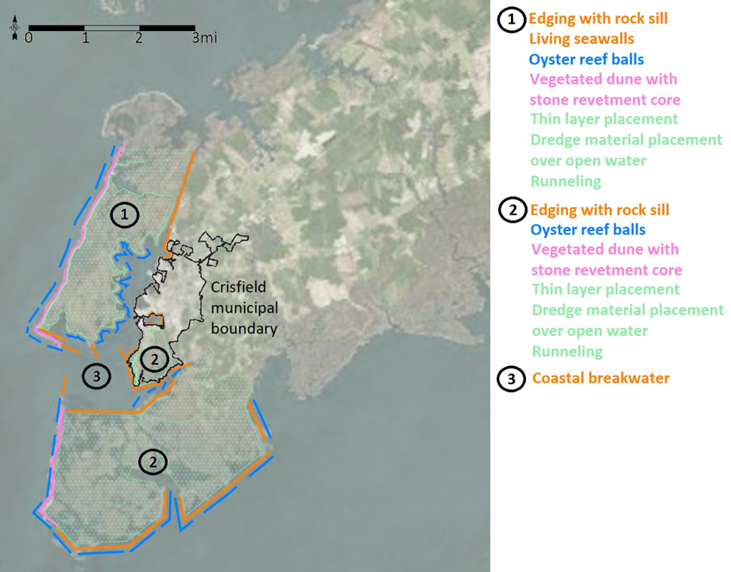

The first project is a proposed marsh restoration (green) for Janes Island, including edge protection via sand dune restoration (pink), offshore artificial reefs (blue), and living shorelines (orange). Similarly, the second project includes the same general suite of strategies for Cedar Island. And, in between, the third proposed NBS project involves constructing living breakwaters in the lower Annemessex River between the two island marsh complexes, including creating seagrass and marsh grass habitat behind the breakwaters for juvenile fish and crab habitat and seeding the structures with oyster spat.

We are on the October 30 agenda to present these three potential NBS projects for Crisfield coastal resilience to the Joint Evaluation Meeting that the Maryland Department of the Environment hosts (<https://mde.maryland.gov/programs/Water/WetlandsandWaterways/Pages/Joint_Evaluation.aspx>) along with other regulatory agencies like the United States Army Corps of Engineers to get specific permitting and implementation feedback.

In the context of today’s technical working group discussion, we want to keep these project options in the back of our mind as we go through the provided spreadsheet of potential co-benefits that we have identified from previous Crisfield community and partner engagement activities.

As a reminder, at the July 31 Technical Working Group meeting, EPA ORD shared 17 categories of co-benefits of Crisfield’s natural spaces collected from community feedback provided at institutional partner and public meetings on April 19 and 20. At the July 31 meeting, we discussed some of the preliminary ways that EPA ORD is starting to model these identified co-benefits of community interest. We want to be sure that we are using the right metrics to represent these benefits and get feedback on whether there are better metrics or more important metrics that should be used and modelled. We also want to prioritize metrics and make sure we are including co-benefits most important to Crisfield and excluding ones that are not as important or will not be affected by nature-based strategies.

At the October 2 meeting, the TWG was shown a spreadsheet of potential measures of co-benefits of NBS (in addition to storm-surge protection) and asked for feedback including (1) whether suggested measures seemed reasonable or alternatives could be identified, and (2) which subset of co-benefits was highest priority to evaluate, based on likelihood of being affected by the proposed NBS options and relevance to Crisfield. For assessing how NBS might help support the seafood industry, the TWG noted that rockfish and crabs are important species that draw people to Crisfield but suggested looking at fisheries landings data to identify most common species. The TWG raised concerns about whether changes in hydrodynamics due to NBS could impact sediment movement, creating potential hazards for navigation or impacting water clarity. The TWG noted that water quality concerns related to water clarity, fish kills, and bacterial counts could impact both commercial fishing and recreation/tourism. Marsh restoration could open up greater accessibility for recreational users and improve habitat for ducks of interest to both hunters and birders. Marsh vegetated to unvegetated ratio and elevation were identified as important measures of marsh condition. The TWG noted that NBS restoration projects could also provide opportunities for students to attain service hours. Additional details on TWG feedback, and the full list of co-benefits metrics can be found in the updated spreadsheet (see file: “TWG mtg #2 co-benefits table plus Feedback.xlsx”). Additional measures, data, and model sources suggested by the TWG are noted in red text in columns E and F. Items for EPA Team follow-up are noted in column I.

The TWG were asked to pick their top one or two most important co-benefits to assess as potentially being impacted by NBS options. Species for fishing/seafood, water quality and its effects on aquatic life, and water navigability all received multiple votes. Recreational opportunities/access, community safety, economic development, and coastal restoration were also mentioned as priorities.

Questions?

[Kashuba.Roxolana@epa.gov](mailto:Kashuba.Roxolana@epa.gov)

[Yee.Susan@epa.gov](mailto:Yee.Susan@epa.gov)

[Eisenhauer.Emily@epa.gov](mailto:Eisenhauer.Emily@epa.gov)

**[END MEETING]**