**CWA Assessment Training Evaluation form**

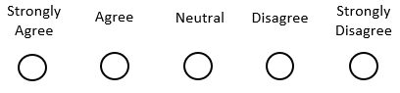**Module 1:**

This training helped me easily understand the topic

The training addresses all the topics I expected

The exercises helped me understand the topic

What did you like about the module?

What didn’t you like about the module?

What would you suggest changing?

**Module 2:**

This training helped me easily understand the topic

The training addresses all the topics I expected

The exercises helped me understand the topic

What did you like about the module?

What didn’t you like about the module?

What would you suggest changing?

**Module 3:**

This training helped me easily understand the topic

The training addresses all the topics I expected

The exercises helped me understand the topic

What did you like about the module?

What didn’t you like about the module?

What would you suggest changing?

**Overall Training feedback:**

****I enjoyed this training

This training is applicable to my job