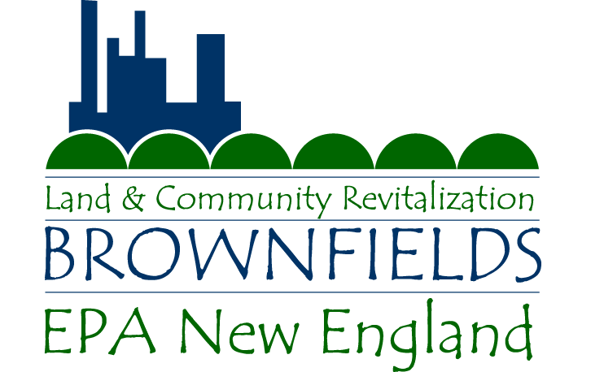 | EPA BROWNFIELDS  TARGETED ASSESSMENT  APPLICATION FORM  (Use only for sites in EPA Region 1) |  |  | 
APPLICANT ORGANIZATION:*
ADDRESS:
CITY: STATE: ZIP:
CONTACT PERSON: PHONE: FAX:
EMAIL:
* If Non-Profit, please attach support letter from municipality where property is located
SITE NAME:
SITE ADDRESS:
CITY: STATE: ZIP:
CURRENT SITE OWNERSHIP:
NAME:
ADDRESS:
CITY: STATE: ZIP:
PHONE (if known):
AMOUNT OF DELINQUENT PROPERTY TAXES (if any): $
ASSESSED VALUE: $ APPRAISED VALUE: $
IF PROPERTY OWNED BY APPLICANT, ACQUSITION BY:
Foreclosure Eminent Domain Purchase (Price: $ ) Other
IF OTHER, EXPLAIN:

DATE OF ACQUISITION:

IF PROPERTY NOT OWNED BY APPLICANT, DOES APPLICANT ENVISION DIFFICULTY IN OBTAINING LEGAL PERMISSION TO ENTER THE PROPERTY TO CONDUCT SITE ASSESSMENT ACTIVITIES? Yes No
EXPLAIN:

IS APPLICANT OR ANY OTHER PARTY UNDER ORDER FROM EPA OR STATE AGENCY TO CONDUCT SITE ASSESSMENT AND/OR CLEANUP? Yes (describe below) No Unknown
BRIEFLY DESCRIBE ANY HISTORICAL OR CURRENT INVOLVEMENT/ROLE OF STATE ENVIRONMENTAL AGENCY IN ENFORCEMENT AND OVERSIGHT OR FUNDING OF ASSESSMENT/CLEANUP OF CANDIDATE SITE:

SITE ZONING: TOTAL ACREAGE OF SITE: (attach site map, if available)
BUILDINGS ON SITE |  | SQUARE FOOTAGE | CONDITION (e.g., usable, partially razed, gutted by fire, etc.)

PAST SITE USES (type of manufacturing, etc.) | APPROXIMATE DATES
PRIOR SITE ASSESSMENT ACTIVITIES:
None Unknown ASTM Phase I (Date Completed: )
TYPE OF CONTAMINATION: Petroleum Only Hazardous Substances
DESCRIBE CONCLUSIONS OF PRIOR SITE ASSESSMENT ACTIVITIES (or attach “conclusion” section of report(s)). IF REPORTS ARE UNAVAILABLE, IDENTIFY CONSULTANT, CLIENT, AND APPROXIMATE DATE OF STUDY:

SITE ASSESSMENT NEED:
DESCRIBE SITE ASSESSMENT ACTIVITIES BEING REQUESTED AND ESTIMATED COSTS:

ANTICIPATED FUTURE USE: Residential Recreational Commercial/Retail Industrial
DESCRIBE APPLICANT’S PROPOSED REUSE PLAN:

DESCRIBE ANY FINANCIAL INCENTIVES PLANNED BYAPPLICANT TO SPUR DEVELOPMENT (tax incentives, etc.):

DESCRIBE PROPOSED FUNDING SOURCES AND AMOUNTS FOR SITE CLEANUP (EPA program is for site assessment only, no cleanup money is being offered as part of this program):

BRIEFLY DESCRIBE ANY PUBLIC INTEREST AND/OR COMMUNITY INVOLVEMENT IN SITE REUSE PLANNING ACTIVITIES TO DATE:

As a result of the Small Business Liability and Brownfields Revitalization Act (Public Law 107-118, 01/11/2002), certain changes were made in the Brownfields program. Petroleum, controlled substances and mine scarred land are now eligible for funding. Additionally, certain sites are no longer eligible for funding and other sites may be eligible for funding after EPA makes a “Property Specific Determination for Funding”. The following questions need to be answered as part of the evaluation process.
SITES NOT ELIGIBLE FOR FUNDING:

- Facilities listed (or proposed for listing) on the National Priorities List.

- Facilities subject to U.S. EPA unilateral administrative orders, court orders, administrative orders on consent, or judicial consent decrees issued to or entered into by parties under CERCLA.

- Facilities that are subject to the jurisdiction, custody or control of the United States Government.

SITES NOT ELIGIBLE FOR FUNDING WITHOUT A PROPERTY SPECIFIC DETERMINATION:

Please answer the following questions to the best of your knowledge:

- Is your site/facility subject to an ongoing U.S. EPA CERCLA removal action? YES NO

- Is your site/facility subject to an unilateral administrative order, court order, administrative order on consent or judicial consent decree or to which a permit has been issued by the United States or an authorized state under the Solid Waste Disposal Act (as amended by the Resource Conservation and Recovery Act (RCRA)), the Federal Water Pollution Control Act (FWPCA), the Toxic Substances Control Act (TSCA), or the Safe Drinking Water Act (SWDA)? YES NO

- Is your site/facility subject to U.S. EPA corrective action orders under RCRA (sections 3004(u) or 3008(h)) and to which a corrective action permit or order has been issued or modified to require the implementation of corrective measures? YES NO

- Is your site/facility a land disposal unit that has filed a closure notification under subtitle C of RCRA and to which closure requirements have been specified in a closure plan or permit? YES NO

- Has your site/facility had a release of polychlorinated biphenyls (PCBs) that is subject to remediation under TSCA? YES NO

- Has your site/facility received funding for remediation from the Leaking Underground Storage Tank (LUST) Trust Fund? YES NO

Note: If you have answered Yes to any of these questions, you will need to prepare a “property specific determination”.
Please contact Alan Peterson at the email address or phone number below for further information.
PETROLEUM ONLY SITES:

Please answer the following questions to the best of your knowledge:

- Please perform a title search and list all of the former owners of the site:

- Did any of the former owners cause/contribute to the contamination at the site? YES NO
Please List:

- Are any of the former owners financially able to conduct the site assessment? YES NO

SUBMIT COMPLETED FORMS TO:

Alan Peterson - Targeted Brownfields Assessment Program Lead
US Environmental Protection Agency - New England Region
5 Post Office Square, Suite 100 (OSRR07-2)
Boston, MA 02109-3912
Phone: (617) 918-1022
Email: peterson.alan@epa.gov

